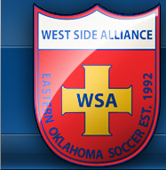

#1 Jacob Lovellee
Wide Forward- WSA 92 Boys

3013 Rosebud Dr.
Sapulpa, OK 74033
918-292-2992
Jacobleovelle@hotmail.com
NCAA Clearinghouse #1304283430
Height: 6’1 Weight 155 Father: Mike
Birthdate: 5/12/92 Mother: Sue

High School ODP Experience
Sapulpa High School 2010 State Team
Class of 2015 2013 Regional Team
G.P.A. 3.47 Rank:13
References
Academic Achievements Ryan Bush
Honor Student ADOC/College Coordinator
Spanish Club rybush@oru.edu
Key Club
Roger Bush
Club Team DOC
Premier League West Qualifier rogerwsa@aol.com
State Cup Finalist
2011 Adidas Final Four Showcase Runner-up Kevin King
2010 Adidas Final Four Showcase Flight Champs Club Coach
2009 Muscatine Showcase Champs I-amballer@hotmail.com
2008 Border Battle Gold Champs

Community Service
John 3:16 Mission
Soccer Camp Counselor

WWW.WSASOCCER.ORG

